“Mockito Hands-On Exercises”
Exercise 1: Mocking and Stubbing Scenario: You need to test a service that depends on an external API. Use Mockito to mock the external API and stub its methods.
SOLUTION
1.ExternalApi.java
public interface ExternalApi {
String getData();
}
2.MyService.java
public class MyService {
private ExternalApi externalApi;

public MyService(ExternalApi externalApi) {
this.externalApi = externalApi;
}

public String fetchData() {
// Calls external API method
return externalApi.getData();
}
}
3.MyServiceTest.java
import org.junit.jupiter.api.Test;
import static org.mockito.Mockito.*;

public class MyServiceTest {

@Test
public void testVerifyInteraction() {
// 1. Create mock
ExternalApi mockApi = mock(ExternalApi.class);

// 2. Inject into service
MyService service = new MyService(mockApi);

// 3. Call the method
service.fetchData();

// 4. Verify interaction
verify(mockApi).getData(); // ✅ Verifies method was called
}
}

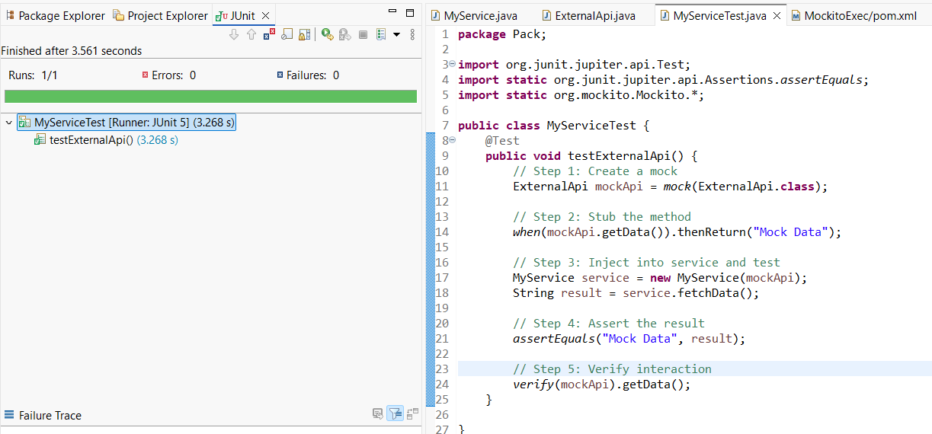
---------------------------------------------------------------------------------------------------------------------------

Exercise 2: Verifying Interactions
Scenario: You need to ensure that a method is called with specific arguments.
SOLUTION
1.ExternalApi.java
package Pack;
public interface ExternalApi {
String getData(String userId);
}
2.MyService.java
package Pack;
public class MyService {
private ExternalApi externalApi;
public MyService(ExternalApi externalApi) {
this.externalApi = externalApi;
}
public String fetchData() {
return externalApi.getData("admin"); // Depends on ExternalApi
}
}
3.MyServiceTest.java
package Pack;
import org.junit.jupiter.api.Test;
import static org.mockito.Mockito.*;

public class MyServiceTest {
@Test
public void testExternalApi() {
// Step 1: Create a mock
ExternalApi mockApi = mock(ExternalApi.class);

// Step 2: Stub the method
when(mockApi.getData("admin")).thenReturn("Mock Response");

// Step 3: Inject into service and test
MyService service = new MyService(mockApi);
String result = service.fetchData();

verify(mockApi).getData("admin");
System.out.println("Result: " + result);
}
}



